Library Management System Database

**Problem Statement:-**

 The purpose of the LIBRARY MANAGEMENT SYSTEM is mainly to provide automation to the library. It include Publisher and Supplier who will publishes and supplies the library items. A Publisher can publish many library items. Similarly a Supplier can supply many library items. Library items further divided into Books, Magazines, Thesis, Journals, where books belongs to category. Library items will reserved and borrowed by borrowers. One borrower can reserve many library items and many borrowers can borrow many library items. Entity librarian who maintains the library items of library. Another entity borrower which will require authentication to enter in library and for issuing the books. Borrowers can be generalize into student, faculty and others.

**E-R Diagram:-**

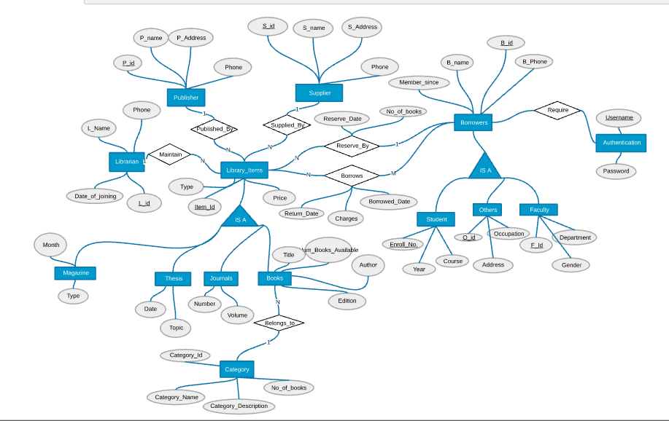

**Relational Schema:-**

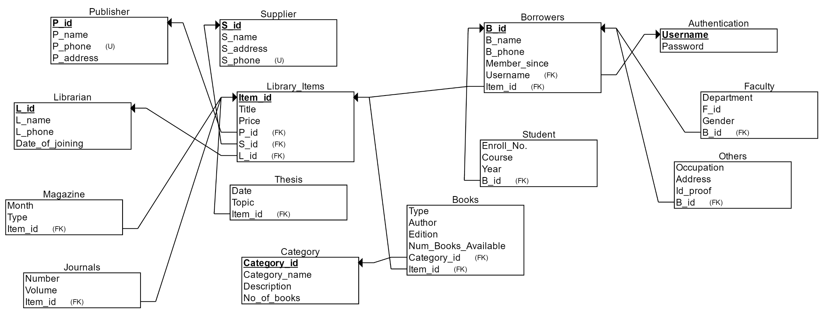

**Table Schema with SQL code:-**

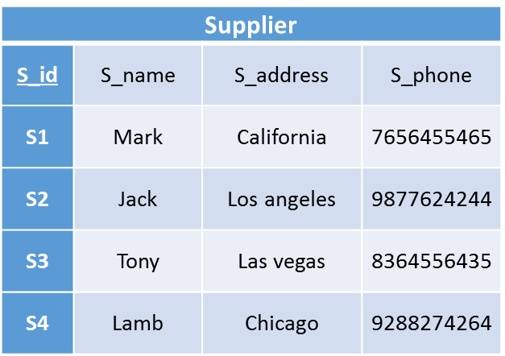

CREATE TABLE Supplier

(

S_id INT NOT NULL,

S_name VARCHAR NOT NULL,

S_address VARCHAR NOT NULL,

S_phone INT NOT NULL,

PRIMARY KEY (S_id),

UNIQUE (S_phone)

);

🡪

CREATE TABLE Publisher

(

P_id INT NOT NULL,

P_name VARCHAR NOT NULL,

P_phone INT NOT NULL,

P_address VARCHAR NOT NULL,

PRIMARY KEY (P_id),

UNIQUE (P_phone)

);

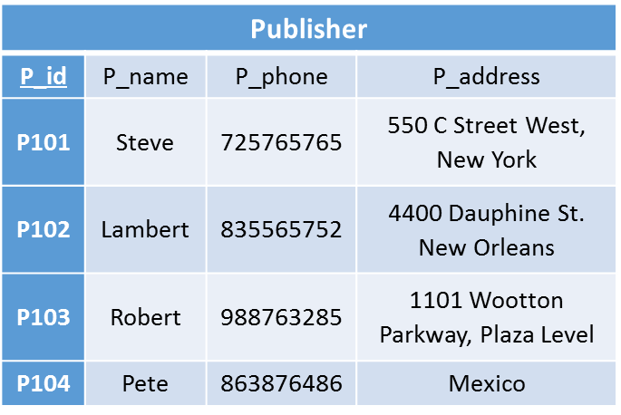

🡪

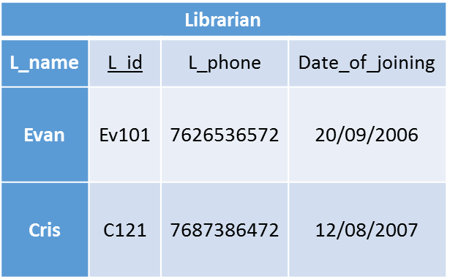

CREATE TABLE Librarian

(

L_name VARCHAR NOT NULL,

L_id INT NOT NULL,

L_phone INT NOT NULL,

Date_of_joining INT NOT NULL,

PRIMARY KEY (L_id)

);

🡪

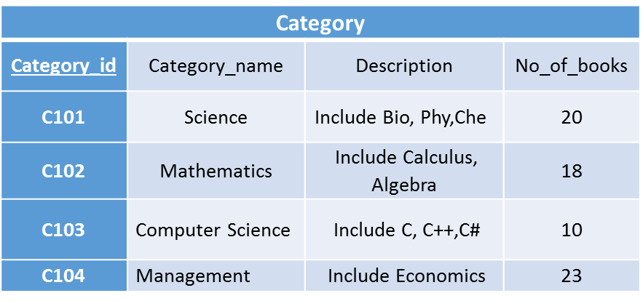

CREATE TABLE Category

(

Category_id INT NOT NULL,

Category_name VARCHAR NOT NULL,

Description VARCHAR NOT NULL,

No_of_books INT NOT NULL,

PRIMARY KEY (Category_id)

);

🡪

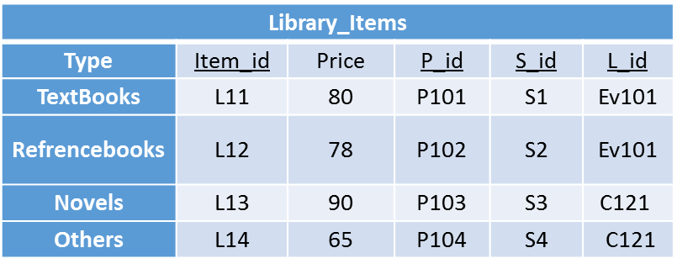

CREATE TABLE Library_Items

(

Title VARCHAR NOT NULL,

Item_id INT NOT NULL,

Price INT NOT NULL,

P_id INT NOT NULL,

S_id INT NOT NULL,

L_id INT NOT NULL,

PRIMARY KEY (Item_id),

FOREIGN KEY (P_id) REFERENCES Publisher(P_id),

FOREIGN KEY (S_id) REFERENCES Supplier(S_id),

FOREIGN KEY (L_id) REFERENCES Librarian(L_id)

);

🡪

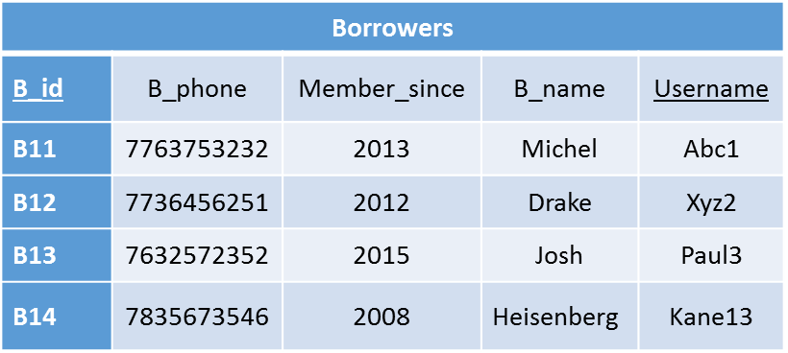

CREATE TABLE Borrowers

(

B_name VARCHAR NOT NULL,

B_phone INT NOT NULL,

Member_since INT NOT NULL,

B_id INT NOT NULL,

Username VARCHAR NOT NULL,

Item_id INT NOT NULL,

PRIMARY KEY (B_id),

FOREIGN KEY (Username) REFERENCES Authentication(Username),

FOREIGN KEY (Item_id) REFERENCES Library_Items(Item_id)

);

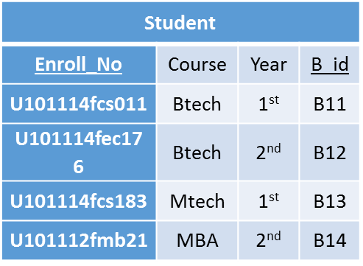

🡪

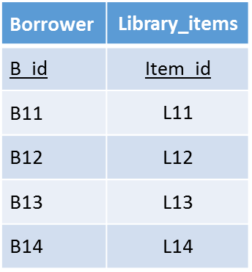

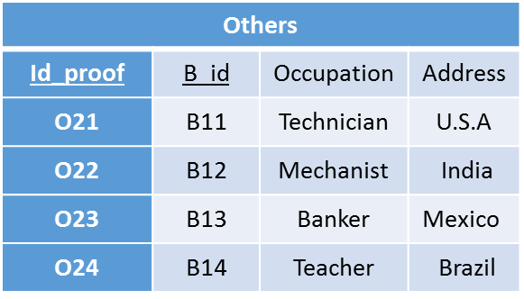

🡪

CREATE TABLE Others

(

Occupation VARCHAR NOT NULL,

Address VARCHAR NOT NULL,

Id_proof INT NOT NULL,

B_id INT NOT NULL,

FOREIGN KEY (B_id) REFERENCES Borrowers(B_id)

);



CREATE TABLE Student

(

Enroll_No. INT NOT NULL,

Course VARCHAR NOT NULL,

Year INT NOT NULL,

B_id INT NOT NULL,

FOREIGN KEY (B_id) REFERENCES Borrowers(B_id)

);

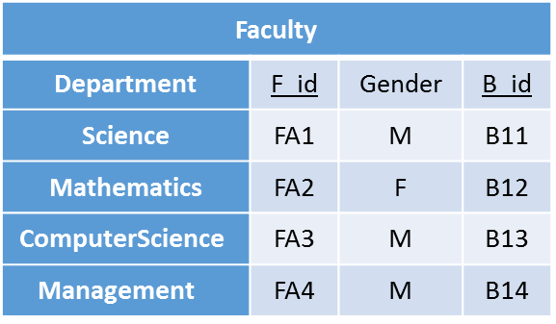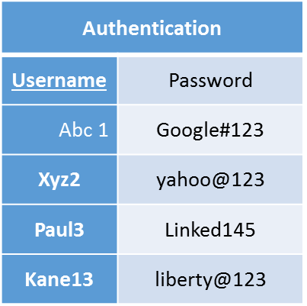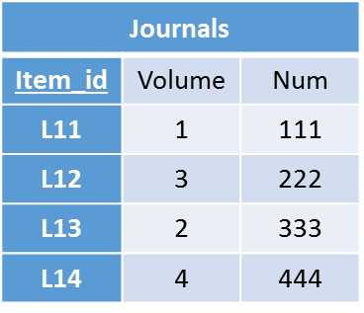

🡪

🡪

🡪

CREATE TABLE Faculty

(

Department VARCHAR NOT NULL,

F_id INT NOT NULL,

Gender CHAR NOT NULL,

B_id INT NOT NULL,

FOREIGN KEY (B_id) REFERENCES Borrowers(B_id)

);

CREATE TABLE Authentication

(

Username VARCHAR NOT NULL,

Password VARCHAR NOT NULL,

PRIMARY KEY (Username)

);

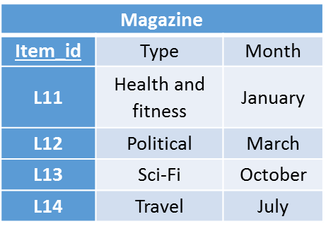

CREATE TABLE Magazine

(

Month INT NOT NULL,

Type INT NOT NULL,

Item_id INT NOT NULL,

FOREIGN KEY (Item_id) REFERENCES Library_Items(Item_id)

);

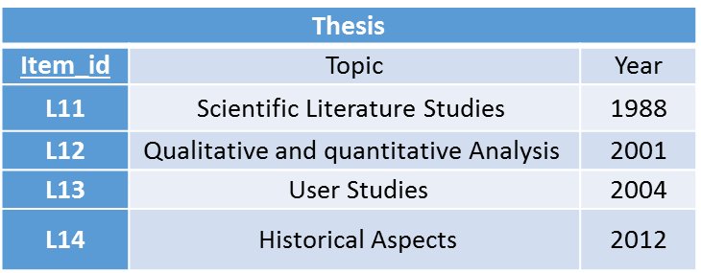

🡪

🡪

CREATE TABLE Thesis

(

Year INT NOT NULL,

Topic VARCHAR NOT NULL,

Item_id INT NOT NULL,

FOREIGN KEY (Item_id) REFERENCES Library_Items(Item_id)

);

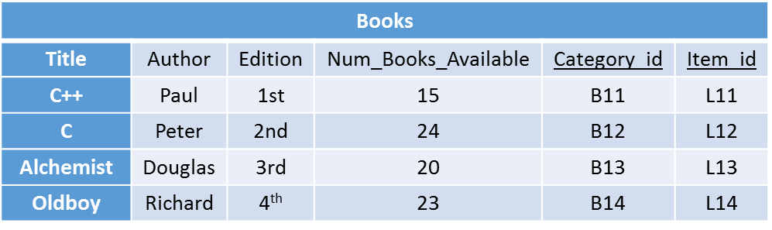

CREATE TABLE Books

(

Type VARCHAR NOT NULL,

Author VARCHAR NOT NULL,

Edition INT NOT NULL,

Num_Books_Available INT NOT NULL,

Category_id INT NOT NULL,

Item_id INT NOT NULL,

FOREIGN KEY (Category_id) REFERENCES Category(Category_id),

FOREIGN KEY (Item_id) REFERENCES Library_Items(Item_id)

);